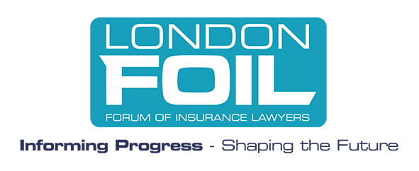
London FOIL’s Focus for 2022
One of London FOIL’s strengths is its ability to look behind the headlines, to use the combined experience of its member firms to inform its thinking and develop innovative and pragmatic ideas and proposals. Invariably, the success or otherwise of reform rests not in the big picture but in the detail. With so much change having happened so quickly, more than ever decisions for the future need to be grounded in analysis and evidence: a clear view on what is working and should be retained, and what needs further change.
As always, alongside its members, London FOIL seeks to work closely with the (re)insurance industry, a sector which has faced its own challenges over the past 20 months both in the claims environment and in a public examination of the role of insurers in delivering financial security and social change. FOIL’s focus is on understanding the pressures and opportunities for the industry it serves and being at the heart of the on-going debates.

Part A. The business world in 2022 – “From Hard Times to Great Expectations”
London FOIL’s work in 2022 will include working with the insurance industry and members to:
- support the insurance industry, with legal advice, innovation and empathy as the sector transitions to sustainable underwriting, employment, investment and purchasing practices,

- work collaboratively with each other to develop plans to bring their firm’s net carbon output to at least zero, with an ambition of a net negative by 2030,

- promote diversity, inclusion and well-being in the workplace,

- support members and insurers as we find the best ways to work together in the future using the lessons learned from the pandemic.
Investors, regulators, customers and employees expect unequivocal evidence of corporate conduct that truly reflects the responsibility of business in these times.
By being at the forefront of these conversations London FOIL will add value for our members and their clients.
Part B. Technical and legal focus
London FOIL’s technical work in 2022 will include:
- Civil Litigation Post-COVID – following the enormous changes to the civil justice regime to keep the system operating during the pandemic, the focus now is on longer term reform – what changes should stay and what further reforms are needed. HMCTS resource is an important issue.

- The on-going fall-out from Brexit – the government may consider Brexit “done” but it continues to throw up legal and regulatory problems. London FOIL will follow closely the caselaw and legislation expected in 2022.

- The challenge and opportunities of technological change and innovation – the pandemic has given increased impetus to the use of technological developments to support new business practices and provide new claims handling solutions. Technology is an increasing factor in damages claims and in the development of insurance products and new areas of cover.

- The on-going impact on the insurance and re-insurance industry of the FCA cases on Business Interruption linked to Covid 19.
Part C. London FOIL’s own development
London FOIL’s strategic focus in 2022 will include:
- Business support – continuing to increase the focus on the benefits to business that collaboration brings for FOIL members, majoring on the increased importance to investors, regulators, customers and employees of a company’s carbon emissions and diversity & inclusion policies.

- Trade Bodies Association – building up this group of like-minded trade bodies into a coherent and powerful lobby.

- Training and Development – design and implement a programme of education to promote insurance law as an attractive career choice to undergraduates and college students.

- Identifying additional areas of interest unique to the London and Lloyds (Re) Insurance market (e.g. Space Insurance) and building SFTs to major on these subjects.

- Expanding and promoting the London Members’ Library.

- Recruiting new members.

Laurence Besemer FCII
FOIL CEO
Gavin Coull – Birketts
London FOIL President

